**CH 245: ORGANIC CHEMISTRY 1 LABORATORY (Fall 2019)**

**Title:**

1. **Purpose: (1 point)**

The purpose of this lab is to be able to separate two immiscible aqueous compounds from each other, in this case, benzoic acid and dimethyl terephthalate, using various methods and equipment such as a separatory funnel, vacuum filtration, and distillation.

1. **Drawing of structure of the main compound or balanced chemical equation if synthesis is performed: (1 point)**

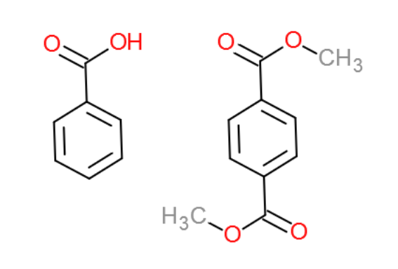

benzoic acid dimethyl

terephthalate

$$PhCOOH_{aq}+K_{aq}^{+}+OH_{aq}^{-}→PhCOO_{aq}^{-}+K_{aq}^{+}+H_{2}O_{l}$$

**3. Reagents and the major product (up to 6 points)**

|  |  |  |  |  |  |  |
| --- | --- | --- | --- | --- | --- | --- |
| **Name** | **M.W.**  (0.5 pts) | **Density**  (0.5 pts) | **Amount (grams/mL)**  (0.5 pts) | **Moles**  (0.5 pts) | **Hazards/Precautions**  **(MSDS data) and melting point or boiling point** (2 pts) | **Waste Disposal**  **(aqueous or organic)** (2 pts) |
| Benzoic acid | 122.12 | 1.27 g/cm3 | 3g | 0.025 | Skin irritation, eye damage | Organic |
| Dimethyl terephthalate | 194.19 | 1.2 g/cm3 | 2g | 0.010 | May cause skin, eye irritation | Organic |
| Potassium hydroxide | 56.11 | 2.12 g/cm3 | 40 mL 1.5M sol. | 0.060 | Corrosive, skin and eye damage, toxic if ingested | Aqueous |
| Hydrochloric Acid | 36.46 | 1.18 g/mL | 10 mL |  | Skin burns and eye damage, respiratory irritation | Aqueous |
| Dichloromethane | 84.93 | 1.326 g/cm3 | 25 mL | 0.390 | Skin, serious eye irritation, respiratory irritation | Organic |
| Magnesium Sulfate | 120.37 | 2.65 g/cm3 | 0.4g | 0.0033 | No information | Aqueous |

**4. Procedure (up to 2 points)**

|  |  |
| --- | --- |
| **Procedure** | **Observations and Lab Data** |
| A summary of the procedure done with bullet points) | Color changes, exothermic or endothermic reactions, gas generation, etc.; tare weights for flasks, etc. |
| * Obtain a 25 mL solution containing 3g benzoic acid and 2g dimethyl terephthalate dissolved in dichloromethane. * Obtain 40 mL of aqueous 1.5M KOH solution. * Place 25 mL DCM solution in separatory funnel and extract twice with 20 mL each of KOH solution and once with 20 mL distilled water. * Combine the aqueous layers in 100mL beaker and label as solution A. * Place DCM layer in 125 mL Erlenmeyer flask and add 0.4 g anhydrous magnesium sulfate. * Label this solution D and set aside. * Cool solution A in an ice bath. * Obtain 10 mL concentrated HCl in a beaker * Add dropwise HCl to solution A while stirring with a glass rod. * Test acidity of solution with pH paper. pH paper should turn red. * Filter the mixture with Buchner funnel and wash with a small amount of cold water. * Collect precipitated benzoic acid and allow to dry for a week. (beaker with parafilm and holes) * Filter solution D with gravity filtration into tared 50mL or 100mL round bottom flask. Add two boiling stones. * Set-up and distill solution D, discarding distilled DCM. * Leave dimethyl terephthalate flask to dry for week (parafilm with holes) |  |

**5.** Results; include actual yield in grams and % yield.

**Results (need to get signed by instructor or TA):**